Best Practices and Tips for Recording a Video
Audio:
1. Find a quiet place where you can control the noise levels (avoid public areas).
2. Turn any mobile devices to silent mode (or even better, switch off).
3. Ensure that you place your audio device 6-12 inches (15-30 cm) away from you, and slightly off center.
4. Try to maintain the same distance from the microphone throughout your recording.

Video:
1. Position your camera an arm’s length away from you.
2. The top of your head should be right at the top edge of the frame with your shoulders showing at the bottom.
3. Stay aligned with the top line of the grid as you can see in image below.
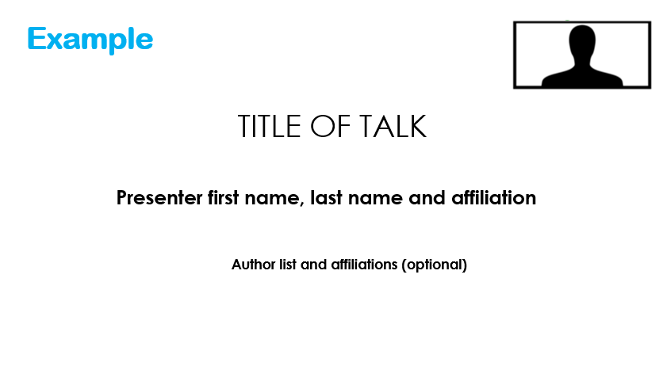
4. Place your device in front of you so that its level, or slightly above your eyeline.
5. Avoid looking down into the camera.
6. When you are presenting, the aim is to have direct eye contact with the audience. Try to look directly into the camera lens, not at the screen.
7. Ensure that your camera is on a steady surface before recording.

Lighting:
• Orientate yourself to ensure that your main light source is facing you head on and not behind you – this "backlight" creates shadow, and most cameras cannot produce quality images if this occurs.
• The more light you have IN FRONT of you, the better your image will look. A window or open bulb desk lamp can be used if light is an issue.

Background:
• Find a professional space if possible. A plain a background is preferable - A white wall, a sheet, whatever you have easy access to.

